Sudan Recovery Map

By

Khalid Tajelsir
Mohammed Abdelkhalig

Submitted in Partial Fulfillment of the Requirements for the Degree of
Bachelor of Science in Computer Science
at
Future University
July/2025

Project Thesis Supervisor
(Razan Haydar)

The Final Project Course Adviser
(Dr. Zeinab M. Sedahmed)

©2025 Khalid, Mohammed. All Rights Reserved

TABLE OF CONTENTS

LIST OF FIGURES III
LIST OF ABBREVIATIONS IV
ABSTRACT V
Chapter 1 1
INTRODUCTION 1
1.1 Background of the Study 1
1.2 Significance of the Study 2
1.3 Objectives 2
1.4 Scope and Delimitations 2
1.5 Conceptual Framework 3
1.6 Definition of Terms 4
Chapter 2 5
REVIEW OF RELATED LITERATURE 5
2.1 Humanitarian Mapping Tools 5
2.2 AI in Satellite Image Analysis 5
2.3 Community Platforms for Disaster Recovery 6
Gaps in Existing Systems and Opportunities: 6
2.4 Geospatial Platforms in Post-Conflict Reconstruction 7
2.5 AI-Based Damage Assessment in Crisis Zones 7
2.6 Participatory Technology and Civic Platforms 8
2.7 Crisis Information Management Systems 8
2.8 Remote Sensing and Change Detection 8
2.9 Digital Platforms for Transparency and Accountability 9
Chapter 3 10
METHODOLOGY 10
3.1 Introduction 10
3.2 Methodological Approach 10
3.3 The model steps: 10
• Development Tools and Technologies 10
• Development Process Steps 11
11
Requirements Gathering 11
• Analysis 12
Figure 3 : Use Case Diagram 14
• ERD (Entity-Relationship Diagram) 15

LIST OF FIGURES

Figure 1 Conceptual Framework 3
Figure 2: Development Process Steps 11
Figure 3 : Use Case Diagram 14

LIST OF ABBREVIATIONS

- ERD – Entity Relationship Diagram
- UAT – User Acceptance Testing
- DFD – Data Flow Diagram
- UI/UX – User Interface / User Experience
- CNN – Convolutional Neural Network
- JWT – JSON Web Token
- NGO – Non-Governmental Organization
- API – Application Programming Interface
- HTML – HyperText Markup Language
- CSS – Cascading Style Sheets
- AI – Artificial Intelligence
- REST – Representational State Transfer
- ESA – European Space Agency
- NASA – National Aeronautics and Space Administration

ABSTRACT

This project aims to support Sudan’s post-war recovery through a web application that provides an interactive platform for mapping affected areas, displaying AI-analyzed satellite images, identifying available services like electricity and water, collecting citizen input, and helping NGOs and government agencies prioritize recovery efforts. It also enables citizens to vote on needs, share local initiatives, and contribute to a living digital archive. The system will enhance decision-making, promote transparency, and foster community participation.

Keywords: Sudan, post-war, AI mapping, citizen engagement, recovery platform

الملخص
يهدف هذا المشروع إلى دعم جهود التعافي بعد الحرب في السودان من خلال تطوير تطبيق ويب يُوفر منصة تفاعلية لرسم خريطة للمناطق المتضررة، وعرض صور الأقمار الصناعية التي تم تحليلها باستخدام الذكاء الاصطناعي، وتحديد الخدمات المتوفرة مثل الكهرباء والمياه، بالإضافة إلى جمع مدخلات المواطنين ومساعدة المنظمات الإنسانية والجهات الحكومية في تحديد أولويات التعافي. كما يُتيح النظام للمواطنين التصويت على الاحتياجات، ومشاركة المبادرات المحلية، والمساهمة في أرشيف رقمي حي يُوثق جهود التعافي.

الكلمات المفتاحية: السودان، ما بعد الحرب، رسم الخرائط بالذكاء الاصطناعي، مشاركة المواطنين، منصة التعافي

Chapter 1

INTRODUCTION

Sudan has entered a critical phase of post-conflict recovery. After suffering widespread destruction, particularly in major cities such as Khartoum, there is a growing demand for innovative tools that can support national reconstruction. This chapter introduces the motivation behind the project, provides background information, explains the scope, and outlines the significance of developing a web-based platform that leverages AI and public engagement to map and assist in Sudan’s recovery process.
- Background of the Study
Sudan has long been challenged by political instability, but the recent war that erupted in 2023 brought unprecedented levels of destruction to the nation’s infrastructure, economy, and social systems. Major cities, particularly Khartoum, faced severe damage to essential services such as electricity, water, transportation, education, and healthcare. The war has displaced millions, interrupted communication networks, and left government institutions struggling to assess and address the scale of the devastation.
In global post-conflict scenarios, technological solutions—especially web platforms powered by satellite imagery and artificial intelligence—have proven valuable in accelerating recovery and enabling more effective aid distribution. Countries like Ukraine and Syria have implemented mapping tools to visualize war damage, inform reconstruction, and engage citizens in reporting on-ground conditions. Unfortunately, Sudan lacks any centralized or digital platform capable of tracking recovery progress, identifying community needs, or organizing collaborative rebuilding efforts.
The lack of real-time information on infrastructure status and local needs not only delays humanitarian response but also disconnects affected citizens from participating in the national recovery process. At the same time, many organizations and volunteers are willing to contribute but are hindered by limited access to verified data or communication platforms.
This project, therefore, emerges from the urgent necessity to provide a digital tool that bridges this gap—a platform that collects and visualizes recovery data, facilitates community input, and guides decision-making for both government bodies and NGOs. It seeks to leverage artificial intelligence and user interaction to deliver a meaningful contribution to Sudan’s long-term recovery and social resilience.
- Significance of the Study
This project provides a vital platform for recovery and redevelopment. It serves multiple stakeholders including the Sudanese government, NGOs, and local citizens. It enables visualization of damage and restored areas, provides real-time service availability updates, and fosters grassroots involvement in rebuilding efforts. In doing so, the platform supports transparency, coordination, and informed decision-making.
- Objectives
Main Objective:
To develop a technological platform that supports Sudan’s recovery through mapping, data collection, and community engagement.
Specific Objectives:
- To build an interactive map displaying affected and restored areas.
- To apply AI to satellite images for pre- and post-war comparisons.
- To show available services (electricity, water) via the interactive map.
- To allow citizens to report needs and share local recovery initiatives.
- To create a real-time feedback loop between citizens and aid planners.
- Scope and Delimitations
Scope: This project targets post-war zones in Sudan. It includes a web-based system with AI satellite analysis, map-based visualization, citizen reports, and public voting on needs.

Delimitations:
- The platform may not cover all rural zones due to satellite imagery limitations.
- Reliance on available AI models may affect image interpretation accuracy.
- User-submitted data may vary in reliability.
- Conceptual Framework
The data will be collected from satellite images and citizen input. Then, it will be analyzed using AI to detect damaged and recovered areas. Finally, the results will be presented on an interactive map to support recovery planning and public participation.
Input: Satellite images, user reports, service provider updates

Process: AI analysis, data categorization, geospatial mapping

Output: Interactive recovery map, visual analytics, reports.

Figure 1 Conceptual Framework

- Definition of Terms
- AI: Artificial Intelligence, used for image analysis.
- Recovery Map: A digital map highlighting damaged and restored areas.
- Citizen Reporting: Submissions by users about local conditions.
- Satellite Imagery: Space-based photos used to visualize terrain changes.
- Post-war Platform: A system built to aid reconstruction after conflict.

Chapter 2

REVIEW OF RELATED LITERATURE
- Humanitarian Mapping Tools
Humanitarian Mapping and Post-Conflict Recovery Platforms In recent years, digital mapping platforms have become critical tools in disaster and post-conflict recovery. Projects like Humanitarian OpenStreetMap (HOT), CrisisMappers, and UN OCHA's ReliefWeb Map Centre have demonstrated the power of crowdsourced and satellite-assisted mapping. These platforms allow users to report incidents, map damaged infrastructure, and visualize access to services in near real-time.
For example, during the 2010 Haiti earthquake, OpenStreetMap was extensively used to map affected areas and guide relief efforts. In Ukraine, satellite imaging and geospatial analysis are used to assess war damage and prioritize reconstruction efforts. Similarly, in Syria, organizations utilized satellite data to monitor the impact of airstrikes and assess the condition of hospitals and schools.
These tools, however, often rely heavily on either satellite input or volunteer contributions, which can limit their accuracy and coverage. Moreover, they are typically focused on short-term crisis management rather than long-term recovery and citizen engagement, which is a key focus of our proposed platform.
- AI in Satellite Image Analysis
Artificial Intelligence in Satellite Image Analysis AI has increasingly been applied to the analysis of satellite imagery, especially in identifying damage from natural disasters and conflicts. Machine learning models can now detect changes in infrastructure, identify temporary shelters, and assess urban growth. Tools such as Google Earth Engine and open-source libraries like TensorFlow have democratized access to these capabilities.
One study by the Stanford Sustainability Lab demonstrated how convolutional neural networks (CNNs) could be trained to identify poverty levels by analyzing satellite images. Another example is the use of AI to estimate flood extent and fire damage, significantly improving the response time and accuracy compared to manual assessments.
In a war-torn country like Sudan, AI-powered satellite analysis can offer an unbiased, rapid, and wide-reaching way to assess the destruction, track rebuilding progress, and inform strategic planning. The proposed system seeks to integrate this technology in a user-accessible platform that not only visualizes data but empowers users to interact with it.
- Community Platforms for Disaster Recovery
Community Engagement and Participatory Platforms Community involvement in crisis management is essential for building trust, identifying local priorities, and enhancing recovery outcomes. Platforms like Ushahidi in Kenya allowed users to report incidents through SMS, web, and mobile apps, which were then visualized on a map. This model was successfully used during political unrest and natural disasters in several countries.
Furthermore, platforms like Map Kibera (Kenya), FixMyStreet (UK), and SeeClickFix (USA) show how local input can be turned into actionable data for municipal services and development projects. These platforms demonstrate the benefits of giving citizens a voice and responsibility in shaping their recovery and development landscape.
Our proposed platform builds on these concepts by combining AI mapping with citizen input and voting mechanisms to prioritize services and interventions. By enabling citizens to directly contribute and see the impact of their contributions, the platform fosters a sense of ownership and collective responsibility for national recovery.

Gaps in Existing Systems and Opportunities: While each of the above-mentioned technologies offers valuable insights, there remains a gap in integrating these components into a unified system that supports long-term recovery and community development. Most existing systems either focus on mapping or citizen reporting but rarely combine them with automated analysis and prioritization tools.
Sudan's current recovery efforts suffer from fragmentation, a lack of verified data, and minimal coordination between stakeholders. There is also a digital divide that excludes many communities from participating in shaping their recovery. Our system aims to address these gaps by providing an accessible, centralized, and intelligent platform that can adapt to Sudan’s unique post-war context.
By combining AI technology, satellite imagery, and citizen engagement in one interface, the project represents a novel approach to inclusive, data-driven recovery planning.

Geospatial Platforms in Post-Conflict Reconstruction
Geospatial technologies have become essential tools in post-conflict reconstruction planning. Platforms such as ArcGIS Online, Google Earth Engine, and Mapbox enable governments and organizations to visualize damage, assess needs, and plan rebuilding in real-time. In post-war Iraq and Afghanistan, the World Bank used satellite mapping to monitor school reconstruction and public infrastructure development. These tools also help in comparing pre- and post-conflict conditions to guide budget allocation. However, most of these systems lack integration with citizen participation and real-time feedback, which our proposed platform aims to address by combining geospatial mapping with crowdsourced data and AI-driven analysis.

AI-Based Damage Assessment in Crisis Zones
Recent studies have shown the effectiveness of artificial intelligence in analyzing satellite imagery for disaster response. For example, the xView2 Challenge by the Defense Innovation Unit encouraged the development of AI models capable of detecting buildings damaged by natural disasters using pre- and post-event satellite images. Similarly, research conducted by the Stanford Sustainability Lab demonstrated how convolutional neural networks (CNNs) could be used to predict poverty levels by analyzing nighttime satellite imagery. These approaches show the potential of AI in extracting valuable insights from visual data. Yet, despite the growing use of AI, many platforms remain inaccessible to local populations or do not reflect on-the-ground realities — a challenge our system addresses by combining automated insights with citizen reports.

Participatory Technology and Civic Platforms
In many crisis-affected areas, participatory platforms have bridged the gap between authorities and citizens. The Ushahidi platform, originally developed in Kenya during political unrest, allowed individuals to report incidents via SMS, and the reports were displayed on an interactive map. This model has since been replicated globally in disaster zones, such as during the Haiti earthquake and the Syrian civil war. In the UK, FixMyStreet enabled residents to report infrastructure problems directly to municipal authorities. While these tools promote engagement, they typically lack AI integration or post-war focus. Our system expands on these efforts by empowering citizens not only to report but also to vote on needs, track recovery progress, and interact with real-time geospatial data.

Crisis Information Management Systems
Crisis Information Management Systems (CIMS) are platforms designed to aggregate and analyze data during emergencies. Examples include Sahana Eden, an open-source disaster management system used in countries like Haiti and the Philippines, which enables coordination between relief agencies, tracks missing persons, and monitors available resources. These systems demonstrate the importance of centralized, accessible information during humanitarian crises. However, they are often tailored to immediate response rather than long-term recovery, and they usually lack integration with AI and interactive maps. Our proposed platform addresses this by blending crisis management, real-time AI analysis, and post-war citizen feedback.

Remote Sensing and Change Detection
Remote sensing technologies, especially when combined with change detection algorithms, have been widely used to monitor urban expansion, deforestation, and conflict zones. Techniques like image differencing and normalized difference indices allow for automated detection of changes in landscapes. For example, during the Syrian conflict, remote sensing was used to monitor the destruction of cultural heritage sites. In Sudan’s context, this technology is particularly valuable due to limited ground access in many war-affected areas. Our platform incorporates this capability through AI-powered change detection applied to satellite imagery, allowing both government and citizens to track reconstruction progress over time.

Digital Platforms for Transparency and Accountability
Transparency and accountability are key pillars in post-conflict governance. Platforms like Open Government Data Portals and Open Contracting Platforms have been implemented in countries like Ukraine and Colombia to prevent corruption and misuse of resources during reconstruction. These systems publish real-time data on budgets, aid distribution, and project status. While not always interactive or citizen-centered, they reflect the global shift toward digital tools that ensure public oversight. Our system shares this vision by offering visual updates on recovery efforts, voting mechanisms, and a participatory archive of community input, promoting open and transparent development.

Chapter 3

METHODOLOGY
- Introduction
The development of this project followed the Agile software development model. Agile is an iterative and incremental approach that emphasizes flexibility, user feedback, and continuous improvement. It allows the project team to work in short development cycles called sprints, each delivering a functional part of the system. This model was chosen due to its adaptability to change and its ability to involve stakeholders throughout the development process, making it suitable for a dynamic and user-centered platform like the one proposed for Sudan’s post-war recovery.

- Methodological Approach
The system will be developed using the Agile development method to ensure iterative feedback and improvement.

The model steps:

Development Tools and Technologies
The proposed platform is being developed using modern web technologies. For the front-end, we use HTML, CSS, Bootstrap, and React.js to create a responsive and dynamic user interface. We also utilize Leaflet.js and Mapbox to build an interactive map that displays affected and recovered areas in real time. On the back-end, we use PHP with the Laravel framework to handle server-side logic and API development. The database is managed using MySQL. This technology stack was chosen for its scalability, community support, and suitability for building robust, data-driven web applications.

Development Process Steps

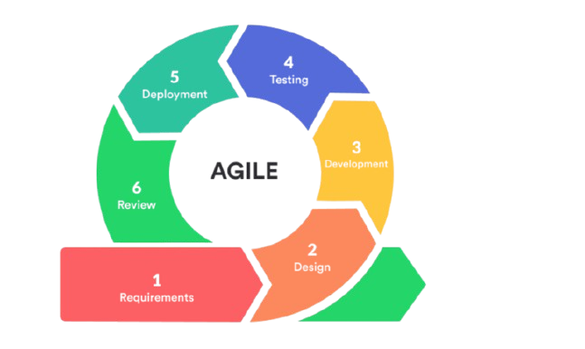
Figure 2: Development Process Steps
;

Requirements Gathering
Data will be collected from: - Open-source satellite datasets - User feedback via forms and reports - Surveys and interviews with displaced citizens
Functional Requirements:
- Interactive map with AI-labeled satellite images
- Real-time citizen reporting system
- Admin panel for NGOs and government agencies
- Voting and feedback system for prioritizing services
- Development Tools and Technologies The system is built using modern web technologies:
- Front-End: HTML, CSS, Bootstrap, React.js, Leaflet.js, Mapbox
- Back-End: PHP (Laravel Framework), RESTful APIs
- Database: MySQL for relational data management
- AI Tools: Python-based image analysis using TensorFlow and OpenCV libraries for change detection in satellite imagery

- Analysis
Current system description: There is no centralized system available; recovery data is fragmented or non-existent. Existing systems used by aid groups are isolated and lack public visibility.
- Proposed system description:
- Central web interface with mapping capabilities - AI-based pre/post comparison of satellite imagery - Citizen reporting system for local needs - Voting mechanism for service prioritization - Administrator dashboards for NGO/government use
- Diagrams and Models:
- Use Case Diagram
- Entity Relationship Diagram (ERD)
- Data Flow Diagram (DFD)
- Development Process The development process follows the Agile lifecycle:
Sprint 1: Environment Setup & UI Skeleton
- Set up development environments and GitHub repositories
- Build initial UI layout and structure
Sprint 2: Map Integration & Satellite Display
- Integrate Leaflet.js and Mapbox for interactive maps
- Display static and dynamic satellite images on the map
Sprint 3: AI Image Analysis Module
- Train CNN models to detect pre- and post-damage
- Integrate AI results with map layers
Sprint 4: Citizen Reporting Module
- Design forms for incident reporting and needs submission
- Store submissions in MySQL with location metadata
Sprint 5: Voting & Feedback System
- Enable users to upvote recovery priorities
- Display popular needs using data visualizations (e.g., bar graphs)
Sprint 6: Admin Dashboard
- Create role-based dashboards for data review, response planning, and reporting
Sprint 7: Testing and Debugging
- Conduct functional and usability tests
- Gather stakeholder feedback and make necessary adjustments
Sprint 8: Deployment and Documentation
- Deploy application to cloud hosting (e.g., Vercel, DigitalOcean)
- Finalize documentation and user guides

- Use Case Diagram:
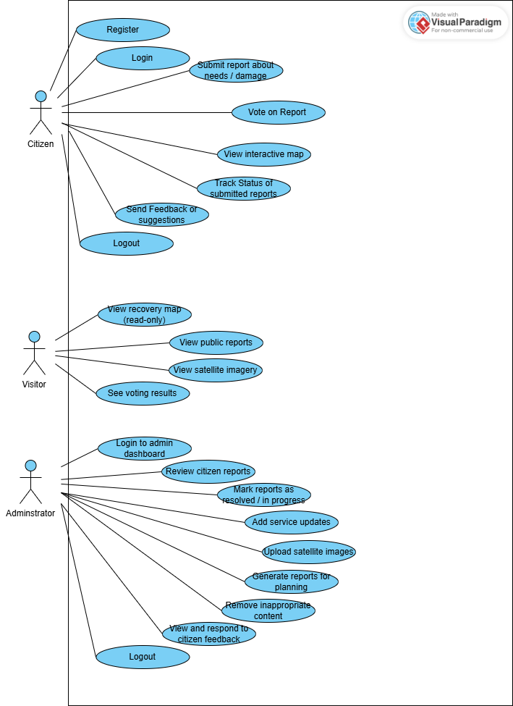

Figure 3 : Use Case Diagram

ERD (Entity-Relationship Diagram)
User:
- user_id (PK)
- name
- email
- password
- role (citizen, NGO, admin)

Report:
- report_id (PK)
- user_id (FK)
- title
- description
- location
- timestamp
- status

Image:
- image_id (PK)
- report_id (FK)
- image_url
- type (satellite / user-submitted)
- ai_detected_damage

Vote:
- vote_id (PK)
- user_id (FK)
- report_id (FK)
- vote_type (upvote/downvote)

Service
- service_id (PK)
- name
- description

Feedback
- feedback_id (PK)
- user_id (FK)
- message
- created_at

